|  |
| --- |
|  |

*User Guide*

COVID TEST and VACCINATION System

**COVID.**

  

**E-PROJECT DOCUMENTATION**

**Faculty: SIR KHALID**

**BATCH CODE: 2111G1**

*COVID TEST AND VACCINATION SYSTEM*

**COVID.**

**Project Group Member**

* **Sayed usman shams**
  + **Enrollment NO: Student1350098**
* **Sayed bilal shams**
  + **Enrollment NO: Student1350097**
* **Abdullah baber**
  + **Enrollment NO: Student1351346**
* **MUHAMMAD Sameer ghori**
  + **Enrollment NO: Student1350060**

**PROJECT DATES:**

Issue date: 12-Nov-2022

Submission date: 12-Dec-2022

**A C K N O W L E D G E M E N T**

**We would like to express our special thanks to our teacher (Sir Khalid) as well as our institute (Aptech) who gave us golden opportunity to do this wonderful project on this topic (Care Group), which also helped us a lot of research and we came to know about so many new things we are thankful to them.**

**Secondly, we would also like to thank our coordinator (Miss ) and friends who have helped us a lot in finalizing this project within the limited time frame.**

**PROBLEM STATEMENT**

**Problem statement is attached separately in a file “COVID TEST and**

**VACCINATION System”**

**Standards plan:**

**Every code block must have comments.**

**The logic of the program needs to be explained. Proper documentation should be maintained.**

**Complete Project Report along with synopsis, code and documentation should**

**be prepared.**

**Documentation:**

**No project is complete without documentation. In fact, it is one of the most**

**important activities during the development of a project. The documentation**

**of an ideal project will be in the form of a project report comprising of the**

**following documents:**

**➢ Certificate of Completion.**

**➢ Table of Contents.**

**➢ Problem Definition.**

**➢ Customer Requirement Specification.**

**➢ Project Plan.**

**➢ E-R Diagrams.**

**➢ Algorithms.**

**➢ GUI Standards Document.**

**➢ Interface Design Document.**

**➢ Task Sheet.**

**➢ Project Review and Monitoring Report.**

**➢ Unit Testing Check List.**

**➢ Final Check List.**

**R E Q U I R E M E N T S P E C I F I C A T I ON**

**Courier management system is currently handled manually by the organization and facing various challenges in maintaining records and providing information to it’s customers. Tracking and handling of couriers is becoming tedious for the organisation.**

**Proposed Solution:**

**Courier management system is a management software designed by considering various factors in courier billing system. The proposed web app will help to manage customer information, package details, generate reports, app billing. Courier management web application will be a comprehensive and complete application will be able to manage all its operations and also the tracking and manage delivery info all registered consignments or packages, manage customer related information. The web app provides necessary info of**

**Admin will update the details of both sender and receiver include status of booked package or consignment. User can tracking the courier through online site.**

**HARDWARE/ SOFTWARE REQUIREMENTS**

**Hardware**

**• A minimum computer system that will help you access all the tools in the**

**courses is a Pentium 166 or better**

**• 128 Megabytes of RAM or better**

**Operating System**

**• LINUX / Windows 2000 Server (or higher if possible)**

**Software**

**• PHP**

**• MySQL**

**• PERL**

**• Apache**

**SITE MAP**

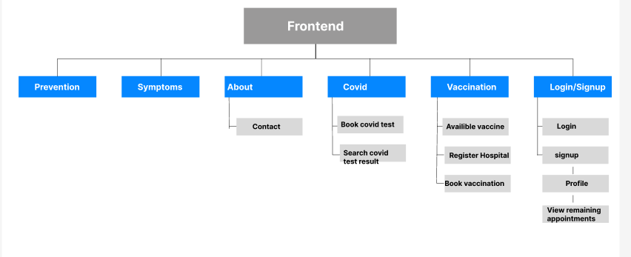

**THANK YOU FOR**

**READING THE**

**DOCUMENTATION.**